Resources:

-FunfFunFunction: https://www.youtube.com/channel/UCO1cgjhGzsSYb1rsB4bFe4Q

-Salesforce Trailhead: <https://trailhead.salesforce.com/users/00550000006yDdKAAU/trailmixes/build-your--developer-career-on-salesforce>

I want to work on being more proactive about networking—reaching out to people on LinkedIn and attending events where I can meet new folks. This morning I reached out to a contact on LinkedIn who was looking for an intern for Salesforce. He wrote back to inform me that I was overqualified for the position, but I'm glad that I took the opportunity to reach out to an unknown contact on LinkedIn for the first time.

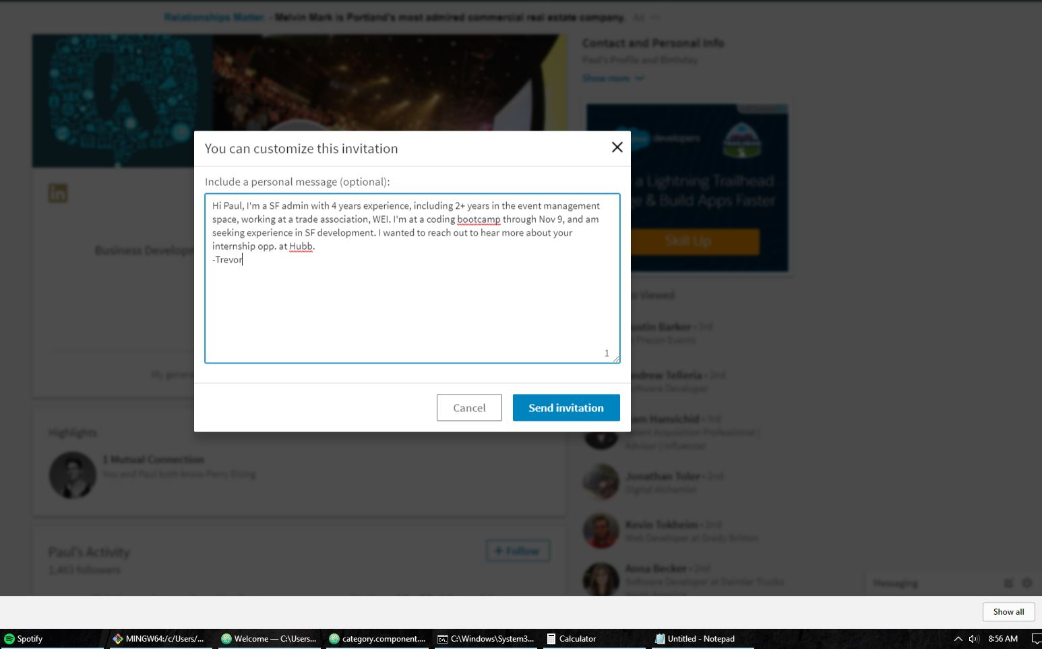

Turned "signal" feature on to let recruiters know that I'm looking for a job, and updated my career interests.

Find the time to attend local events



Avoid getting overwhelmed

Since my plan is to work in Salesforce development, I'll need to figure out the best tools available for doing work in that platform. Salesforce has it's own built-in developer console, but most people say that it's pretty limited in it's capabilities and recommend using a 3rd party IDE instead. I've done some research and have identified 2 good free options: Mavensmate extension for Atom and Sublime (Mavensmate is a Salesforce consulting firm) and JedIDE plugin for IntelliJ. Not only are these two of the most highly recommended tools for Salesforce development, but they're applications that I already have experience with through Epicodus. I have already installed Mavensmate for Atom, connected to a free Salesforce developer org, and have started working through a simple development project in the Salesforce beginner developer Trailhead in.

